BACK-HOES BH220

Use and Maintenance
Manual

AGRIWAY SRL
Via dell’Industria n° 9-9/a-9/b 60030 MONTE ROBERTO (AN), ITALIE
Tél.: (39) 0731375970 - Fax: (39) 0731375990
e-mail: contact@agriway.it –
web: http://www.agriway.it

Harmonized norms

The backhoe has been designed in accordance with the norms described in :the EEC Directive 89/392, 91/368, 93/44 and 93/68 and particularly it satisfies the following Harmonized norms:
EN 292-1: Machinery safety - Basic concepts, general principles of design Part 1: Terminology, basic methodology (1991) - ' .

EN 292-2 : Machinery safety - Basic concepts, general principles of design Part 2: Specifications and technical principles (1991) -. -

EN 292-2/A1: Machinery safety - Basic concepts, general principles of design Parte2 /A 1:Specifications and technical principles (1995)

All rights reserved. No part of-this manual-may be reproduced, in any form or by any means. Only the manufacturing firm can modify the contents of this manual without notice to; the Customer.
Contents
INTRODUCTION 5
A1. Preliminary information 5
A2. Warranty 5
A3. Information on the manual 5
A4. Identification 5
A.5 Main components 6
B.SAFETY 8
B1. General rules 8
B2. Safety conditions for transport, installation and use 8
B2.1 Transport by motor vehicle 8
B2.2 Transport by tractor 9
B2.3 Installation 10
B2.4 Use 11
B3. People safety precautions 13
B3.1 General instructions 13
B3.2 Personnel qualifications 13
B3.4 Pictograms 14
B4. Prohibitions of use (additional) 16
C.INSTALLATION 17
C1. Preliminary information 17
C2. Installation on the three-point attachment 17
C3. Installation of additional struts / tie rods 20
C4. Installation of fixed fastenings 21
C7 Bucket replacement 24
C8. Tractor balancing 24
C9. Removal 24
C10. Storage 24
D.OPERATION AND USE 25
D1. Use 25
D1. 1 General instructions 25
D1.2 Get on the backhoe 26
D1.3 Seat adjustment 26
D1.4 Backhoe stabilization 26
D1.5 Working speed 26
D1.6 Excavation 26
D1.7 Moveable-chassis sliding 27
D1.8.Use in cold weather 27
D2. Operation 27
D2.1 Control distributor 27
D2.2 Control levers 27
D2.3 Sliding-stop switch 29
D2.4 Pressure relief valve 29
E.MAINTENANCE 31
E1. Maintenance warnings 31
E2. Planned maintenance 32
E2.1 Daily check 32
E2.2 Monthly check or after 150 operation hours 32
E2.3 Yearly check or after 1200 operation hours 33
E3 Lubrication 33
E3.1 Grease supply points 33
E3.2 Tank oil level check 35
E3.3 Tank oil level recovery or oil replacement 35
E3.4 Multiplier oil level check 35
E4. Troubleshooting 37
F.DEMOLITION 38
F1. Differentiated subdivision of materials and disposal 38

INTRODUCTION

A1. Preliminary information
All the backhoes are provided with a copy of this manual. The instructions included in it are good for all the models, of the series except if otherwise specified.

(operators) who use the backhoe and must be' done before any use. Unfamiliarity with the machine,, an improper use of it and the disregard of the safety rules could cause serious accidents to the operator⁻ and/or damages to the backhoe. Both of them can be avoided by observing meticulously the instructions contained in this manual.

A2. Warranty
AGRIWAY S.RL. (hereafter called Manufacturer) ensures a six month warranty for all the models. This warranty comes into force- from the delivery date of the Manufacturer's test report card. In fact, the Customer is bound to fill in the card in every part of it and send it to the Manufacturer after having accomplished the installation, checked that the tractor/backhoe coupling is fit and after having performed operation tests. If during these -procedures the Customer finds defective parts or thinks that the coupling is not fit, it is essential to contact the Manufacturer immediately. At any rate, it is important that the Customer verifies he has received the Manufacturer's test report card before using the backhoe. Not receiving the -Manufacturer's card deprives not only the machine of the warranty but releases the Manufacturer from every responsibility.
If during the warranty period a piece is determined to be defective (for workmanship and/or material the Manufacturer or by-him-entrusted technical personnel will replace it at no charge. The replaced "piece-is Manufacturer's, property. Failures due to improper use of the backhoe, operator carelessness, accidents or normal wear out, are riot covered by the warranty.

A3. Information on the manual
This manual must be carefully preserved, undamaged in all parts of it and kept on the operating machine for any reading.
If there are misunderstandings when reading the manual, it is advisable to get in touch with the Manufacturer who will supply the appropriate
explanations to improve the manual, making it- more comprehensible and sending the modified pages to the Customer.

A4. Identification
Each backhoe is identifiable through Manufacturer's name, model and serial, number. Such data, are punched on a special metallic nameplate located/well in sight on the backhoe chassis. On the nameplate they are also- stamped the year of construction, the weight in kg and the operating pressure in bar.

IMPORTANT
It is strictly forbidden to alter and/or erase the information stamped on the nameplate or on other parts of the backhoe.

A.5 Main components

* Note; The tractor specific characteristics permitting, refer to the use and maintenance manual of the tractor to check if the tractor is fit for the backhoe installation
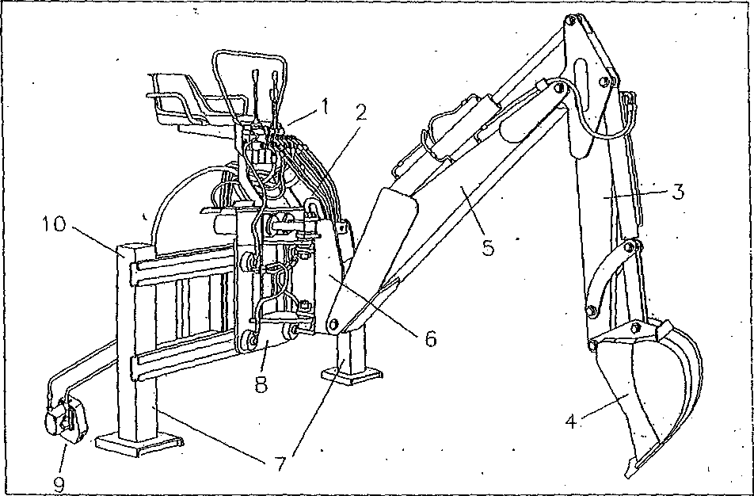
1 | Control distributor
2 | Lifting hooks
3 | 2nd arm
4 | Bucket
5 | 1st arm
6 | Revolving group
7 | Feet
8 | Moveable-chassis -
9 | Pump/multiplier group
10 - Slide-frame

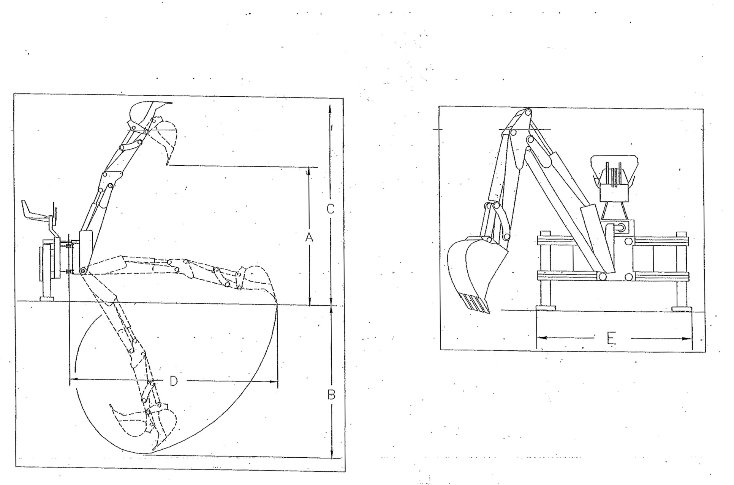

B.SAFETY

B1. General rules
The disregard of tine most basic safety rules causes most of the work accidents. Most of them could be avoided by arranging the appropriate safety measures in advance.
Therefore, it is mandatory to read this manual and follow meticulously the instructions in it contained before using the backhoe. The use of this equipment is to be entrusted to of age and qualified personnel who will be trained for this job. Therefore, the Manufacturer is not answerable for accidents caused by the operator carelessness or by the disregard of safety rules. ..."

B2. Safety conditions for transport, installation and use

B2.1 Transport by motor vehicle
A backhoe, either delivered by the Manufacturer or received by the Customer, has to be set up to transport configuration (as shown in figure) so as to make it steady on any sort of vehicle.
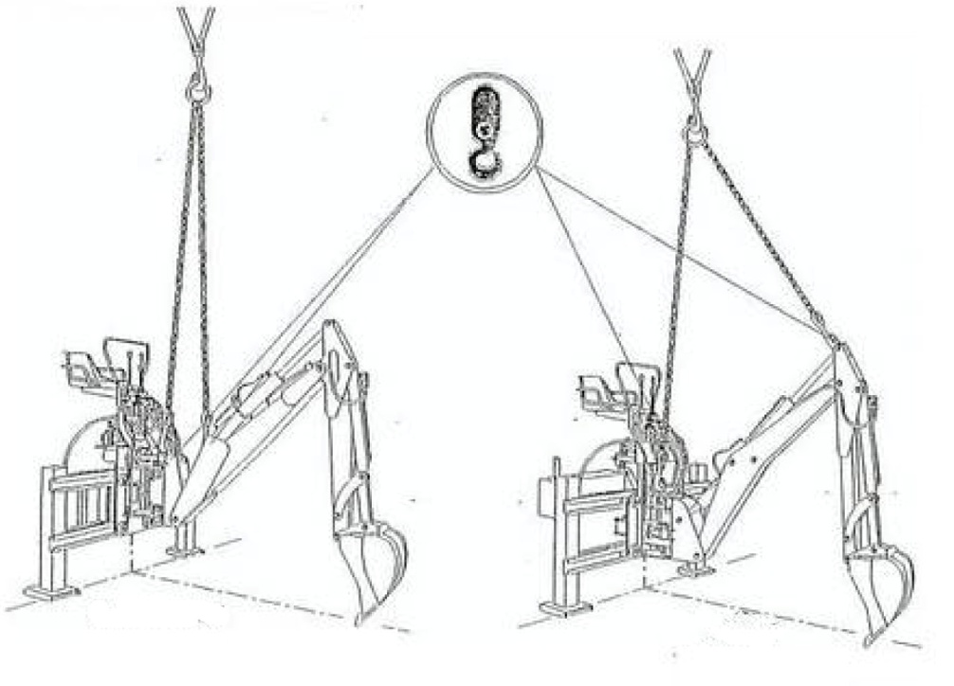

Shift the moveable-chassis to the middle of the slide guides;
Lower the stabilizing feet completely;
Lower te2nd arm (jack fully extended) completely;
Unfold completely the bucket (jack completely retracted);
Lower the bucket to get it to lay on the ground so it will be the third point
of support, (the other two are the stabilizing feet) of the backhoe.
At this point, the backhoe is ready to be lifted by a crane and laid on the vehicle. For such operation it is necessary to use a crane with characteristics and slings fit to sustain its weight which is indicated on tine identification nameplate.

Note: as shown in the figures, the hooking points to lift varies from a series to the other and are easy to be noticed because an adhesive label located near them shows a hook which underlines their use

B2.2 Transport by tractor
A specific transport configuration has to be kept by the backhoe installed on the tractor when it is to be carried on road or to a different workplace.' This configuration is necessary because the backhoe weight, which affects the tractor steadiness, will be evenly distributed on the whole frame. Further information on the tractor steadiness and, in the event this is uncertain, on the, need of putting some ballast, will be furnished after. The transport configuration for both the series is set up as follows:
shift the moveable-chassis, making it to slide to the limit stop (completely on the right or on the left) of the proper slides;
fold back the bucket completely (the jack is fully extended) as shown in figure;
lower tire 2nd arm completely (tire jack is fully extended) and rotate the revolving group of 90° toward the fixed chassis;
lower tire 1st arm as much as it is necessary for getting the bucket fastened to the slide with the proper chain, as shown in figure. This precaution is required for avoiding any possible involuntary motion of all tire jacks. Close to tire two fastening points (on the bucket and on the slide) it has been attached an adhesive label which shows a padlock to underline that those points are used for locking the machine;
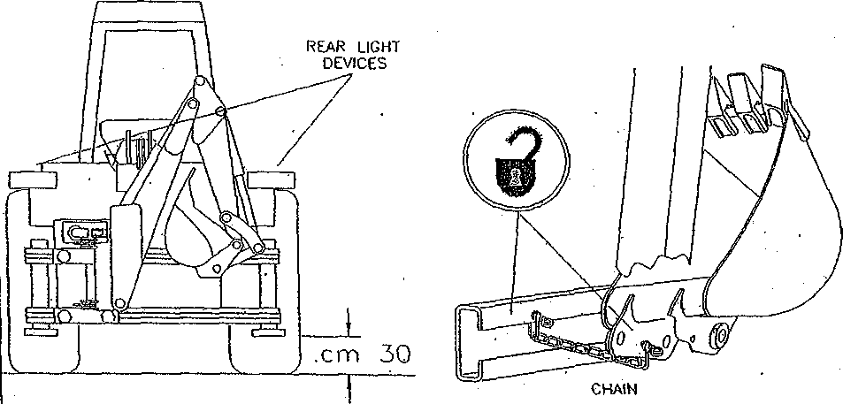
e. lift the backhoe by means of the tractor lift system so as to make the lowest point be at least 30 cm above ground. Then, lock the lift control lever and put out the power takeoff;
f. before moving, the operator has to check that the tractor rear light devices are visible and not covered by the backhoe shape as shown in figure.
In the event they were not visible, see to place some other ones in a visible position. This is required for the road circulation.
g. IMPORTANT: the defective efficiency of the hydraulic stabilizers
could cause their lowering while driving the tractor, creating
dangerous conditions Always check the perfect efficiency of the stabilizing jacks, distributor and relative system.

B2.3 Installation
The backhoe is normally installed on farm tractors, using their universal three-point attachments located on the back. Tractors must obligatory be provided with protective Roll-bar or cabs furnished with ROPS or FOPS type approval as indicated by the rules in force.
It is possible tire installation of the backhoe on carriages or excavators provided they have the safety protections in accordance to the rules and the required characteristics specified by AGRIWAY

IMPORTANT : the customer is bound to check if the installation of the required backhoe model is possible by referring to the use and maintenance manual of the tractor.

In order to circulate on road, it is important to observe the following obligations;
- the machine must always be set to transport configuration;
- attach the specific signs to highlight the machine rear dimensions and,
therefore, the tractor dimensions. For this purpose it is better to
remember that:
the FRONT OVERHANG must not exceed 60% of the length of the unballasted tractor;
the BACK OVERHANG must not exceed 90% of the length of the unballasted tractor;
ALTOGETHER THE LENGTH must not exceed tire double length of the unballasted tractor;
the WIDTH of the backhoe must be less than 2.5 m;
tire SIDE PROJECTION of the backhoe must be less than 1.6 m with respect to the longitudinal symmetrical .line of the tractor. In case the maximum width of tire backhoe was greater than 2.5 m or the side projection was greater than 1.6 m, it is necessary ANAS (National Road Board) permission (for the state roads) or Region permission (for the others);
panels signaling the backhoe dimensions must be attached on the three visible sides and must be retroreflecting and fluorescent, yellow and red striped and type approved;
- tractor visual warning and lighting devices must be repeated in a different position if the backhoe dimensions hid them from sight;
- tractor flashing light device must be in operation;
- when the devices are repeated, they must have their own switch;
- the backhoe control unit must be protected with a special small chassis
with the purpose to avoid unintentional setting at work of the levers;
tractor power takeoff must be put out with the lever locked;
- TOTAL MASS must not be greater than 30% of tire tractor NORMAL
one which is indicated on its logbook;
- the MASS transmitted on the road by tire driving axle, in static
conditions, must not be less than 20% of the NORMAL MASS;
- speed must be reduced, above all on rough roads;
- comply with the rules of the road in force in each Country.

B2.4 Use
The backhoe must perform only the jobs which it has been planned and built for: excavation and earthwork. These jobs must be carried out only with accessories provided by the Manufacturer. Therefore, it is forbidden both the use of the backhoe in a different manner respect to the allowed one and the employment of implements which the Manufacturer-has not planned for use
(orange-peel bucket, magnet, grab bucket, etc.). Besides, the backhoe
technical characteristics must not be altered for changing its performances.
In both situations, machine warranty and Manufacturer's liability will be
void.
Before using the backhoe it is necessary to survey the workplace. If there are electric lines near there, ask tire competent authority for information about their rated voltage.
If it is hot possible to de-energize them, work keeping them at the following safety distances:

Voltage min. distance (m)
up. to-1000 v(lkv) 1
over 1 kv and up to 110 kv 3
over 110 kv and up to 220 kv 4
over 220 kv and up to 3 80 kv 5

IMPORTANT: if-it is not possible to know the rated voltage of the line, always keep at a distance of 5m.
Ask the competent corporation if there are water or gas piping in the area where the backhoe is going to be used. In this case, work with the greatest caution, at low speed and, anyway, in the presence of technicians appointed by the competent corporations. Use the backhoe in the same way if you find out sewers or other utilities .
The backhoe has been designed for working between -5 to +40°C. Beyond, this range of temperature, the Manufacturer is not answerable for accidents or a defective working of the backhoe.

It is important to select the ground where the stabilizers are to be placed. It has to be free from obstructions and able to bear stresses caused by the stabilizers and by the backhoe at work.
Near slopes or ditches,: the safety distance is empirically calculated on the basis of the type of the ground in the following way;
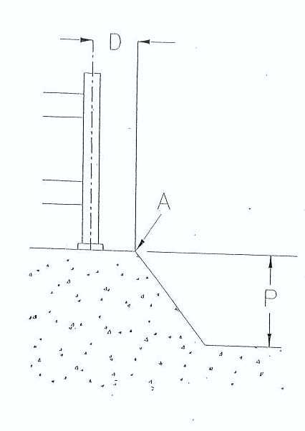
- if the ground is solid, D (minimum safety distance) is to
to be equal to P (depth of the ditch)
D = P
- if the ground is loose or subject to landslides, D (minimum safety distance) is
to be. equal to P (twice the depth of tire ditch):
D = 2P
- Note: the minimum safety distance is measured from the edge of the ditch A, as shown in figure
IMPORTANT:
The operator must never use the backhoe with the stabilizers raised from the ground;
he must check that the ground which he is going to work on, doesn't have a slope above 10%;
he must be sure that the whole machine is placed on the ground in a steady manner;
DANGER OF OVERTURNING:
for operations performed with the arm rotated over 30° with respect to the direction of the tractor, as shown in figure, it is mandatory to perform them only on even surfaces, paying the greatest attention.
In fact, wrong operations, especially if the surface is not even, may get the backhoe overturned. Therefore, it is advisable to use the arm always lined up to the direction of the tractor.
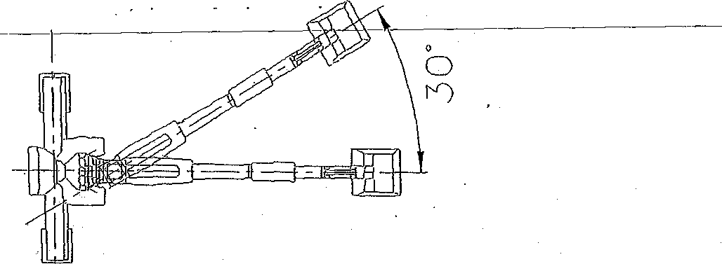

B3. People safety precautions

B3.1 General instructions

Before and while using, the machine, the following precautions are to be observed by tire operator:
B before getting off the tractor, put on the parking brake, shift the gear lever into neutral position and lock the hydraulic lift lever in neutral position;
■ do not use the backhoe if you do not know how it works. Before using . .the machine the operator must learn the control of all the levers and their
operational sequences. However, even an experienced operator must check the machine controls before the use;
before putting on the power takeoff make sure that the number of revolutions is 540 per minute;
do never leave the tractor power on (with possible use of the backhoe) and, anyway, when you stop it, carry out all the operations which ensure-it safety and stability (see paragraph relating to tire parking of the tractor). If it is necessary to stop working for a short time, besides the before mentioned precautions for the tractor, it is necessary to check that the backhoe is well-placed on the ground;
■ no people or animals must be carried on the backhoe;
■ no one is to be allowed to get in and stay in the backhoe working area;
■ on the basis of the noise heard from the. backhoe driver's seat, consider the necessity to use ear protections (earplugs, ear protectors, etc.)- hi this regard, refer to the use and maintenance manual of the tractor as well.

B3.2 Personnel qualifications
The person who uses or sets at work the backhoe must be qualified and must necessarily answer to tire following requirements:

physical characteristics: good eyesight, coordination and ability to perform confidently all the operations required for the use;
mental characteristics: ability to understand and apply the established norms, rules and safety precautions. Moreover, he must be careful and wise for his own safety and for that of the others. He must wish to perform the job correctly and in a responsible way;
training: he must have read and studied this manual, possible illustrations and schemes attached, notices and warning signs. He must be skilled and qualified in all tire aspects of use and maintenance.
B3.3 Working clothes
When working but especially when performing maintenance or repairs, it is to be used the following accident prevention items and garments:
helmet
safety shoes;
face shields for eyes and face protection-
protective gloves;

B3.4 Pictograms
Besides the indications included in this manual, the personnel is helped by some adhesive labels which, attached on varied parts of the machine, show the safety rules to be observed. Labels are different in shape and colors according to the requirement. So, the person who works must know that round-shaped signals stand for obligation (light blue and white colors) or prohibition (red, white and black colors), whereas triangular-shaped ones give warning of danger (yellow and black colors). Other rectangular-shaped labels in addition to warnings of danger or prohibition give further information on the safety rule to be observed. Safety requirements shown on the labels attached on the backhoe are;
danger of serious bodily lesions.
Mark out tire backhoe working area with a white/red striped identification tape on the basis of the turning movement of the 1° arm;
(signal in addition to tire previous one) danger of serious bodily lesions. The presence of people inside the working area when the machine is working is extremely dangerous;
danger of crushing and/or shearing upper limbs. Use a lot of caution;
it is mandatory to read or refer to the use and maintenance manual;
it is forbidden to perform lubrications, adjustments, repairs or cleaning
of the machine when it is in use. If necessary, proceed with a lot of
caution;
only when circulating on the road) reflecting panels to signal the back
of the tractor and, therefore, the rear dimensions of the backhoe;
danger of crushing and/or shearing lower limbs. Use a lot of caution;
pay attention to the number of revolutions shown on the tractor and, therefore, to the power takeoff outlet. It must be 540 rpm;
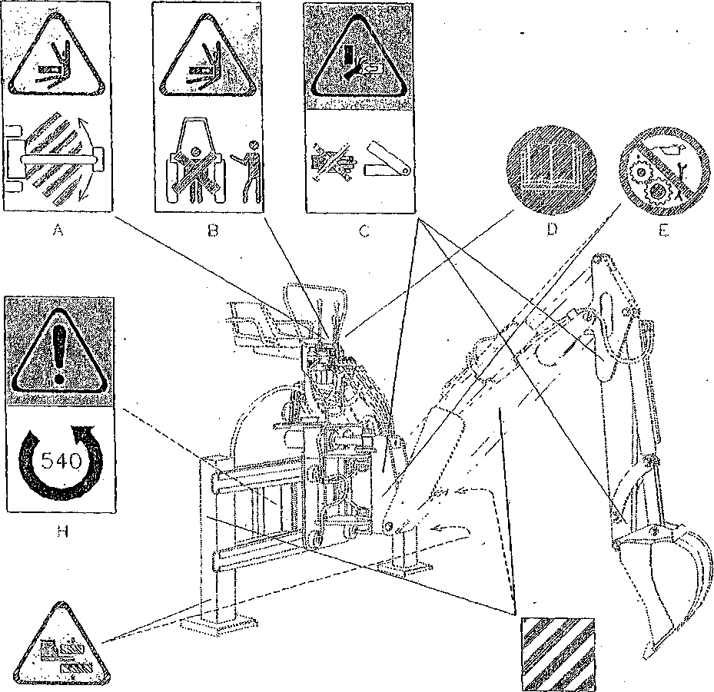

IMPORTANT: It is mandatory to replace adhesive labels before they become illegible. In the event one of them does, the operator is not allowed to use the backhoe until a new one is stuck.

B4. Prohibitions of use (additional)
The use of the backhoe is forbidden:
- in fire risk areas;
- in places with a corrosive atmosphere or with dusts harmful for the
. operator's health
- in rooms with low ceilings and/or closed spaces;
- next to masonry walls which do not allow enough safety conditions
for the planned movements of the backhoe;
- under plants or other hindrances. A wrong move could make the
whole tractor to be lifted, pushing it toward hanging hindrances.

C.INSTALLATION

C1. Preliminary information
Backhoes can be installed on all the tractors provided they have a three-point attachment (see paragraph B2.3 'Installation'). In order to carry out the installation it is necessary to put it within an area of even surface prepared for the operation. The operator who performs the job must be acquainted with the safety rules relative to the installation and must work with tire greatest attention and caution.

IMPORTANT
the alignment of the holes of the tractor attachments with those matching on the backhoe chassis (operation called centering), must never be done by hand but by using a suitable tool.
at the end of the installation procedure, fill in the card enclosed at the end of this manual, cut it as shown and send it to Agriway

C2. Installation on the three-point attachment
First of all, the operator has to lower the tractor hydraulic lift completely and then he has to drive to tire backhoe slowly to perform the centering. At the
end of the manoeuvre, the operator stops the tractor, leaves the lift in the low position, locking its control lever, puts the parking brake on, disengages, in
tire event, the traction control system and draws out the keys from the dashboard.
Once off the tractor, the operator inserts the lift arms (6) into the respective backhoe chassis attachments (5) and secures them, one at a time, with the lockpins (4) which he makes fast with the safety-pins (3). After that, he inserts the adjustable tie rod (7) into the proper seat on the tractor (maximum tractive power point) and makes it fast with a lockpin and a safety pin.
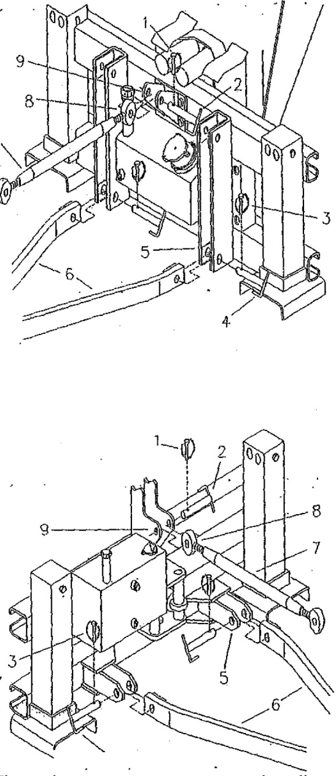
Then, he unscrews or screws the adjustable backhoe tie rod body, letting free the screw nut (8), as much as it perfectly meets its seat on the backhoe chassis (9). He fastens the tie rod with the lockpin (2) and makes it fast with the safety-pins (1). Afterwards, he adjusts the tie rod by screwing or unscrewing its body as much as to get the backhoe chassis be PERFECTLY VERTICAL, and after that, tightens the lock nut. At last, he fastens the hydraulic lift arms with the tie rods or chains they are equipped with. At the end of the backhoe installation on the tractor three-point attachment, he absolutely has to check the coupling configuration. For such check proceed according to tire following instructions and carry out them meticulously.
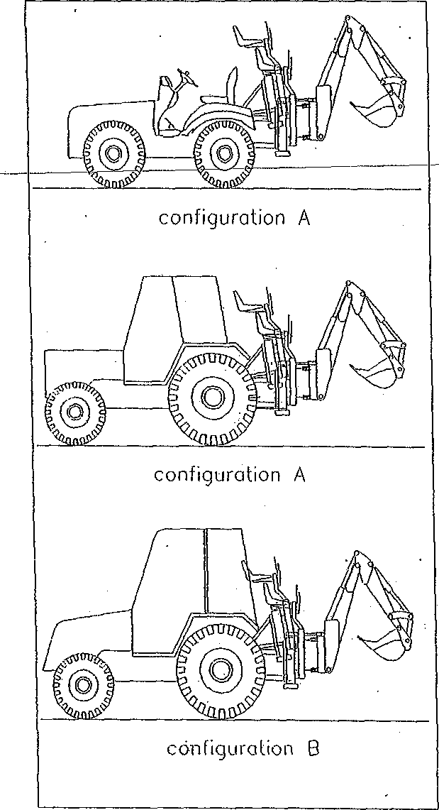
Start, up the tractor and, being at the driver's seat, :. slowly and carefully put tire hydraulic lift into action as shown in figure. While lifting the backhoe check that its driver's seat or parts of it do not cause trouble to tractor parts like protections, ROPS, rear window, etc. (configuration A). If this happens (configuration B), tire Manufacturer will require that the Customer installs additional struts/tie rods in addition to the; three-point attachment. This installation is required for all the operations of the tractor/backhoe group even during the transport.
IMPORTANT: . the
requirement of struts/tie rods is due to tire reason that, especially while working, their installation prevents any move, between the tractor and. tire backhoe, which may cause dangerous conditions for die operator. Besides, this installation improves ergonomics conditions.

C3. Installation of additional struts / tie rods (on demand)
Before performing-the installation of the struts/tie rods it is necessary to operate the; tractor hydraulic lift to lift the backhoe as high as the stabilizing feet are 25 cm .above the ground. According to the backhoe model, the installation of the struts/tie rods is as follows:

Agriway’s series—the two struts/tie rods (2) are to be coupled to the inside lower holes of the backhoe external side attachments and to the upper holes of the tractor central support (as shown in figure). On the backhoe, remove the safety-pins (4) and pull out, one by one, the lockpins (3) enough to insert the screw nuts of the 2 struts into the respective seats. Insert the lockpins completely so as to lock them with the safety-pins. On the tractor, instead, place the struts, one by one, to the central support, lining up the respective holes and insert the through bolts or the lockpins (1) which the tractor is equipped wife. Lock fee bolts or the lockpins with the respective safety-pins. –
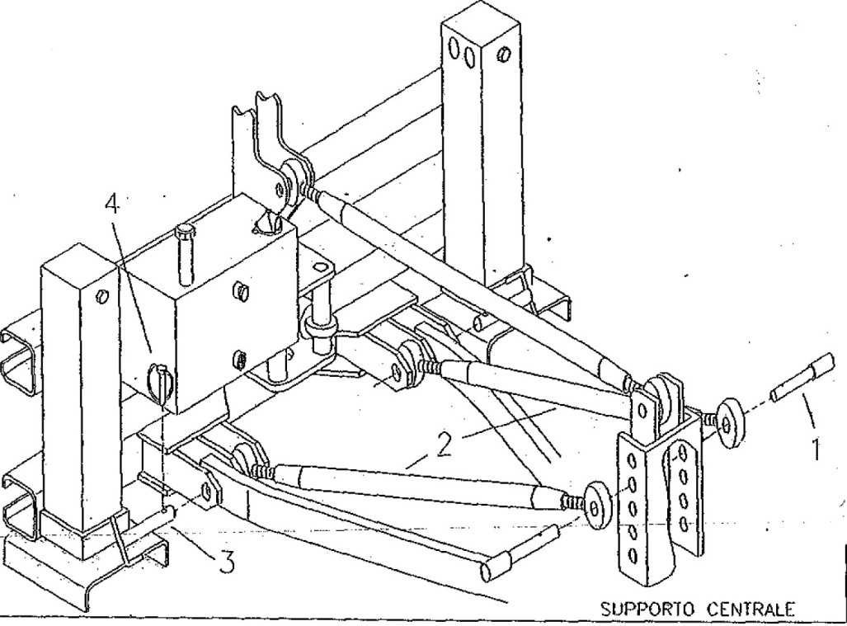

IMPORTANT; after the installation of the struts/tie rods check that the following conditions are respected:
■ the vertical angle formed by the strut/tie rod respect to the horizontal plane (ground level) is to be greater than or equal to 30°;
■ the horizontal angle formed by the strut/tie rod respect to the vertical plane is to be less than or equal to 20° as planned with the maximum inclination of the ball joint;

C4. Installation of fixed fastenings
The backhoe/tractor coupling can also be made by installing fixed fastenings. The design and carrying out of a fixed fastening require a personalized study which takes into account tractor and backhoe technical characteristics as well as an appropriate analysis of the risks for such coupling, considering all the rules in force. Therefore, the Manufacturer can supply a personalized fixed fastening and the required instructions for the use and the installation which can be carried out only by qualified personnel. It is clear that the fixed fastening is furnished only on Customer's demand.
C5. Backhoe with autonomous hydraulic system
All the backhoe models are generally provided with autonomous hydraulic system equipped with tank, filters and pump/multiplier group. In order to activate the backhoe hydraulic circuit it is necessary -that its pump/multiplier group is joined to tire tractor power takeoff. Therefore, as first thing to do, it is necessary to check that this is ready to work with a speed of 540 rpm and with a right-hand rotation. Warning: the installation must be carried out with the engine off. Join the pump/multiplier group (3) to the tractor power takeoff and make it fast by fastening the special plate (5) with the chain (1) to a fixed point of the tractor (generally next to the 3rd attachment, as shown in figure). The chain locked with a safety device.(2) will help to prevent the rotation and tire disengagement of the group.
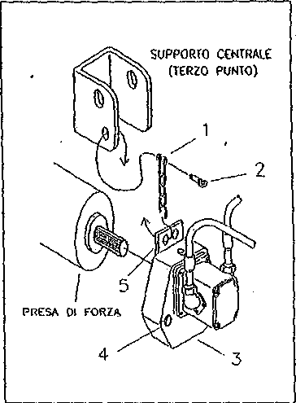
IMPORTANT: when a backhoe is installed for the first time it is advisable that it runs idle for some minutes. The activation of all the jacks allows performing the bleeding of the air left in the hydraulic circuit.
Note: check that no oil dripping or leaks occur, otherwise proceed to stop them.

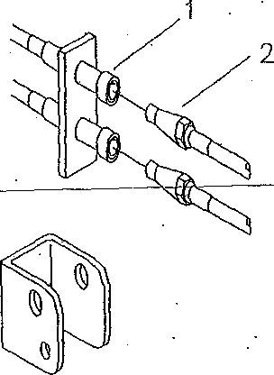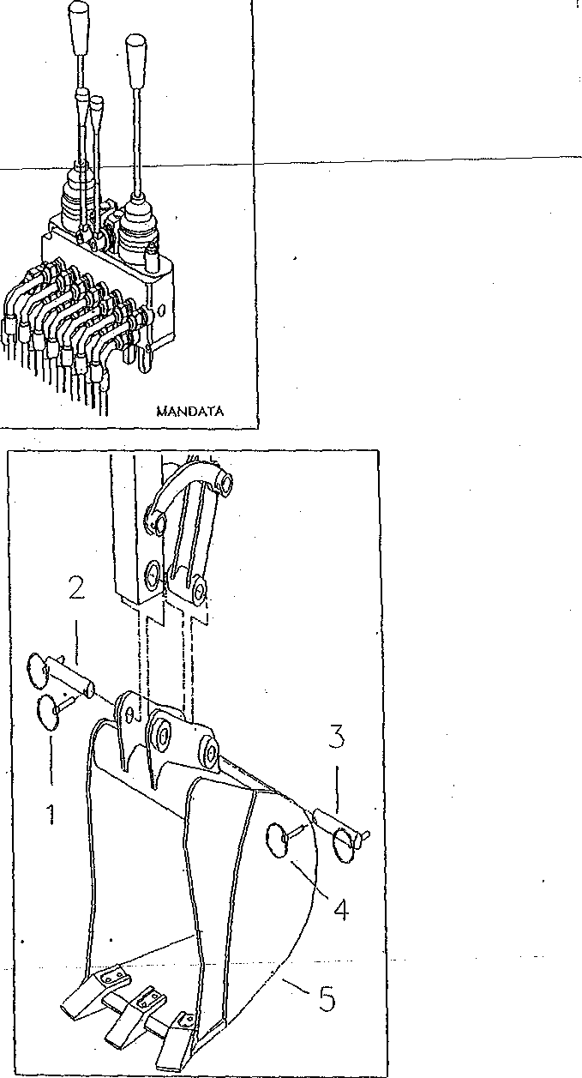C6. Backhoe without autonomous hydraulic system
SUPPORTO CENTRALE (TERZO PUNTO)

Every backhoe can use directly, in alternative to the autonomous hydraulic system, the tractor auxiliary one. In this case, the backhoe hydraulic circuit, through quick coupling pipes, will be connected to the tractor auxiliary one. On Customer's explicit demand, the Manufacturer will provide the backhoe equipped with quick coupling pipes. For this type of connection it is necessary that the tractor auxiliary circuit has a double-acting distributor. It would be better if the specific lever stopped on DELIVERY position instead of returning automatically to neutral position.

IMPORTANT: if the circuit of the tractor has a distributor with two-way and three positions lever, with the possibility to reverse the flow, it is necessary to know the DELIVERY position if it is not indicated. As you find it out seeing the use and maintenance manual of the tractor, mark and lock the lever in that position. That's because, if the oil circulation direction is accidentally reversed the backhoe hydraulic circuit will be seriously damaged.

Before performing the connection it is advisable to clean both the inlet connections and the quick couplings with a rag. Generally, inlet connections on the tractors are always female type (as shown in figure) and located one above the other, in vertical direction, so as that the one (above) will be the delivery pipe inlet and the other (below) will be the return pipe inlet. On the backhoe, instead, the delivery pipe will always be connected on the side of the distributor pressure relief valve (as shown in figure). Insert the quick couplings (2) of the delivery and return pipes of die backhoe hydraulic circuit into the respective inlets (1) located on the back of the tractor.

IMPORTANT: when a backhoe is installed for the first time it is advisable
that it runs idle for some, minutes. The activation of all the jacks allows
performing the bleeding of the air left in the hydraulic circuit.
Note: check that no oil dripping or leaks occur, otherwise proceed to stop
them.

C7 Bucket replacement
Before this operation it is necessary to
carry out the following steps:
- on the tractor: switch off the engine and put on the parking brake;
- on the backhoe: operate the 2nd arm control lever slowly in order that the resulting fall of pressure in the hydraulic circuit gets the bucket to .settle on the ground because of gravity.

At this point, you can go on to its removal. Pull out the two cotter pins (1 and 4) with a hand and always with a hand, pull out, one by one, the two lockpins (2 and 3).
Start up the tractor, get on the backhoe and slowly operate the control lever of the 2nd arm which, lifting, will get free from the bucket (5).

IMPORTANT: it .could happen that the bucket remains attached to the 2nd arm and then it falls. For this reason it is necessary that nobody stops near the backhoe during this operation.
Move the 2nd arm to above the attachment points of the bucket which has been selected for the use. Move the 2nd arm slowly as far as the backhoe attachments meet the bucket ones. Stop the tractor to complete the installation.
Insert the lockpins (2 and 3), one by one, and lock them with the cotter pins (1 and 4).

C8. Tractor balancing
Some tractors become less steady and safe because of the load supported after the installation of the backhoe. This is the cause of unbalances with possible overturning particularly while moving. In order to avoid this trouble it is necessary to distribute the loads on the machine (tractor/backhoe) so as to get the needed steadiness. This operation consists of putting the ballast on tire front of the tractor and/or setting tire driving wheels to the maximum track, as shown in figure. For this job it is necessary' to read the use and maintenance manual of the tractor. .

C9. Removal
In order to remove tire backhoe from the tractor, perform the instructions reported in this chapter backwards.

C10. Storage
Park the machine in a secluded and safe place and on an even and solid surface;
remove the tie rods if they are still installed and keep them;
lower the stabilizing feet completely and set up the backhoe to transport-by-motor-vehicle configuration (see paragraph B2.1);
lower the tractor hydraulic lift and put the stabilizing feet on the ground;
remove die backhoe from the tractor;
lock levers 2 and 3 (see paragraph D2.2) with the special stop so as to avoid that an accidental activation of them results in a jack release and a subsequent move and fall of die backhoe.
cover it with a tarpaulin.
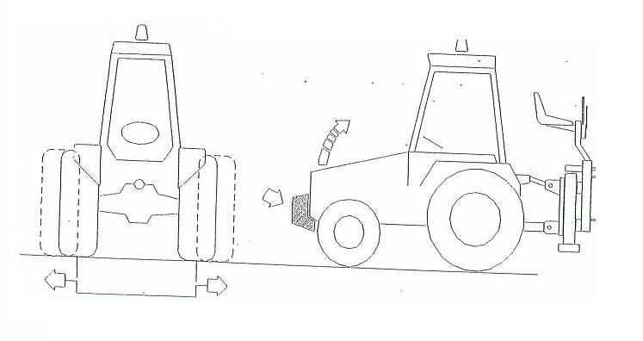

D.OPERATION AND USE
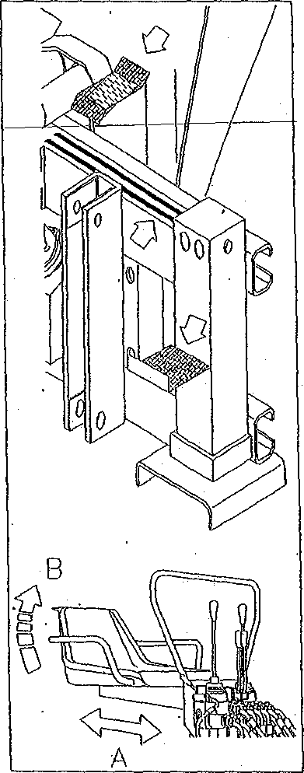

D1. Use

D1. 1 General instructions
• As said before, the backhoe must be used only by an operator qualified and trained for its use and operation. Accordingly, he must know perfectly the instructions reported in this manual, those stamped on all
the adhesive labels, how the controls work and all the safety rules for his
own and the others' safety and for the backhoe safeguard. For the best use and operation of the backhoe, it is necessary to keep to the programs of maintenance planned by the Manufacturer and described below;
• before activating the power takeoff, it would be better to check the multiplier hydraulic oil level (see 'Maintenance' section) and make sure that the area surrounding the backhoe is free from people, animal and things. Warning: do not put the power takeoff on when the engine is off; Start up the tractor engine and put on the power takeoff leaving it to run at a low number of revolutions.

IMPORTANT;
before getting off the tractor, put on the parking brake, shift the gear lever into neutral position and lock the hydraulic lift lever in neutral position.
for safety reason, it is forbidden to move the tractor using the thrust of the backhoe arm.

D1.2 Get on the backhoe
In order to get on the backhoe, the operator has to use the specially designed footrests installed on the chassis or made easily visible by black adhesive bands, as shown in figure. Do not use other parts of die chassis as foothold or handhold. Hold yourself up with your hands to tire seat and the bar of protection of tire levers. Footrests must always be kept free from grease, oil and mud.

D1.3 Seat adjustment
Once on the backhoe, the first thing for the Operator to an is to adjust the seat so as to get a comfortable, safe and, therefore, ergonomic position. The seat can slide horizontally on the support (A}below and/or be adjusted in its inclination (B) by means of a screw located under it. It is advisable to keep the seat always free from grease, oil and mud and to test its integrity frequently.

D1.4 Backhoe stabilization
When the tractor engine is on and the backhoe is ready to work, operate, one by one, the stabilizer control levers until the stabilizing feet are firmly placed on the ground. The lowering of the stabilizing feet causes the rising of the back of the tractor, so it is advisable not to unload excessively the back wheels. Along the slopes, for safety reasons, it is advisable to . place . the machine in longitudinal direction with the tractor below. Remember, finally, that the slope must not be over 10% for safety reasons and for stability.

D1.5 Working speed
Backhoe working speed depends on the number of revolutions of the tractor engine which determines the oil delivery in the pump/multiplier group. At the beginning, it is advisable to speed up the engine to 900 rpm. At this speed rate, check the controls, familiarizing with the levers, then speed it up to 1300 rpm. At this point you can start to work.

D1.6 Excavation
This job is to be performed after having stabilized the backhoe. Extend both the 1st and tine 2nd arm. so as to get an angle of 120° between them. Unfold the bucket completely and lower it to the ground. The excavation is gotten with a combined action, bucket / 2nd arm: the folding of the bucket allows it to penetrate and pick up, while the lowering of the 2nd arm lifts the bucket with the load.

Note: operate first the bucket and then the 2nd arm. Manoeuvres different from the described one are absolutely forbidden.
For a correct way of working it is advisable not to insist on one control only but to alternate them continually so as to distribute the stress on die ground evenly. This will improve the bucket penetration.
IMPORTANT: DANGER OF OVERTURNING - the excavation process should not cause the detachment of the stabilizers from the ground. If this had to happen it could cause the machine overturning. Therefore, it is forbidden to perform earthworks with the stabilizers not firmly placed on the ground.

D1.7 Moveable-chassis sliding
The arms/bucket group can be shifted along the whole slide-frame by sliding the moveable-chassis on which the group is installed along the proper slide guides. According to the type of locking, the sliding is performed as follows:
- mechanical locking:
loosen the four self locking nuts that lock the sliding of the moveable-. chassis and, therefore, of the arms/bucket group; turn the arm to the direction where you want it to slide. Unfold the bucket-and place it firmly against the ground. Perform a pulling action on the bucket by moving both the arms so as to get the moveable-chassis to shift. Lock its sliding by tightening the four self locking nuts;
- hydraulic locking:
turn the flow switch located below the distributor to 'OPEN’ position to switch off the four cylinders which prevent the arms/bucket group and, therefore, the moveable-chassis on which the group is installed, from
sliding. Turn the arm to the direction where you want it to slide; unfold the bucket and place it firmly against the ground. Perform a pulling action, on the bucket by moving both the arms so as to get the moveable-chassis to shift.
Lock its sliding by turning the flow switch back to 'CLOSED' position and make any jack go to the limit stop.

D1.8.Use in cold weather
The use of the backhoe in cold weather with temperatures between - 20° and 5°C requires the following steps:
- use a hydraulic oil fit to such temperatures. It is advisable to refer to a lubricant chart to chose it;
- before beginning to work, make the pump run idle for about 5 minutes so as to bring both the oil and the pump/multiplier group to the operative temperature. Subsequently, make all the controls run idle as well, for some minutes, so as to bring the hydraulic system to die operative temperature.

D2. Operation

D2.1 Control distributor
The backhoe is put into operation by a control distributor which is installed on the chassis (as shown in figure) and easily run from tire driver's seat. The distributor is equipped with an anti-shock valve, a control stick, and a pressure relief valve. Some types of distributors are also provided with a sliding-stop switch of the moveable-chassis.

D2.2 Control levers
Control levers can be shifted into two or four positions and are self-returning: when they are released they get back to the initial or neutral position automatically. The shifting of a lever into a certain position allows the performing of a precise operation as the unfolding of the bucket. All the operations described below with the relative shifting of the levers are shown on an adhesive label placed on the chassis close to the control distributor. Generally, there are four levers. When the backhoe is provided with additional piping to feed an implement different from the bucket, the levers are five. Levers and controls activated by them are the following:
1- lever
Bucket
1st arm
2- lever
Right stabilizer
3-lever
Left stabilizer
4 - lever
Rotation
2nd arm

Note: moderate shifts of the levers allow to perform little and gradual movements. With levers at the limit stop it is allowed the highest speed of movement. Do not keep long the levers at the limit stop so as to avoid overheating the hydraulic oil.

IMPORTANT: in order to get the highest operation-efficiency and the highest safety level it is necessary to shift the control levers gently. In
such way you will get slow, jerkless or bumpless movements.
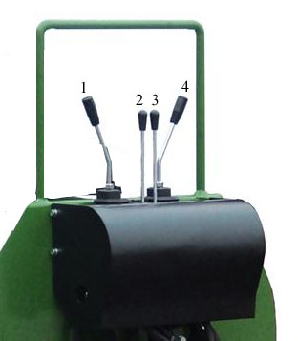

D2.3 Sliding-stop switch
This switch is exclusively installed on backhoes with hydraulic locking. In fact, such device serves to lock the sliding of tire moveable-chassis (with arms/bucket group), thus allowing the backhoe to be used. For this reason, the switch must be always in 'CLOSED' position. In this position, the hydraulic oil under pressure flows to the sliding stop cylinders which, installed on the moveable-chassis, are operated to prevent any sliding of it. The switch positions 'CLOSED' and 'OPEN' are shown next to the device. On some types of backhoes the switch, even maintaining the same characteristics, is placed on the distributor.

D2.4 Pressure relief valve
Setting or possible corrections are performed only by the Manufacturer who seals the valve (with red varnish or with a lead seal) to avoid it to. be tampered.

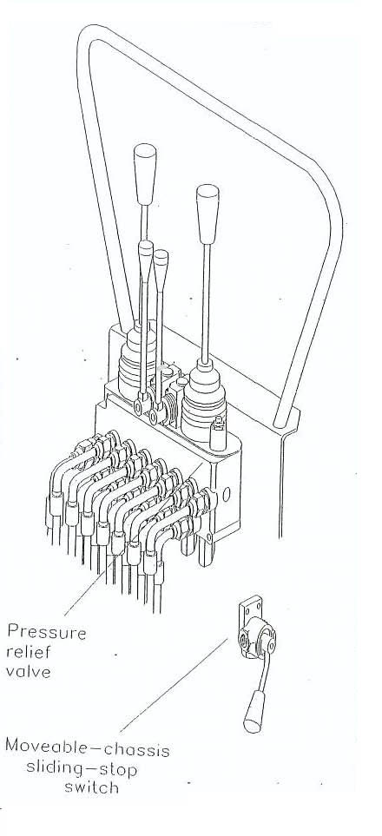

E.MAINTENANCE

E1. Maintenance warnings
After some operation tests, the Manufacturer- has arranged some programs of maintenance for the backhoe. If they are regularly followed and scrupulously performed by the Customer, they will keep the machine efficiency and working capability unchanged, saving it from any working trouble.
The operator must be qualified and trained for carrying out such operations and has to observe what is the following:
- once repairs and maintenance tasks begin, they must be completed and never postponed;
- he must not rely on his memory but he must always read the instructions
reported in this manual;
- before any operation, however, the operator must attach a fully visible
warning poster, "MAINTENANCE IN PROGRESS", both on the
backhoe and on the tractor, for his safety and for preventing damages to
the machine;
- any operation is to be performed on an even surface, tractor stopped (wedges under the wheels), hand brake on, power takeoff switched off, engine off, keys drawn out from the dashboard and backhoe firmly placed on the ground and in vertical position. In the event you have to carry out maintenance tasks on a disassembled backhoe, it is necessary that it be set up to transport-by-motor-vehicle configuration (see paragraph B2.1) with the relative safety locking procedures (see' paragraph CIO 'Storage');
- it is absolutely forbidden to carry out repairs or maintenance tasks while the engine is on and the hydraulic system is working;
- the use of tools to perform maintenance tasks is subordinate to the relative accident prevention rules. Anyway, do not use tools in an improper way, as for instance, using petrol to clean or a pair of pliers in place of an adjustable wrench;
- use only original spare parts or products approved by the Manufacturer.

At the end of maintenance tasks or repairs, clear the workplace of water, oil, grease, greasy rags, tools or other material.
IMPORTANT
- Be very careful when checking leaks of fluid under pressure, because it, escaping through nearly invisible small holes, can pierce the skin and cause serious infections. Therefore, it is necessary to proceed with a lot of care, using protective gloves and goggles with side protections. Provide yourself with a piece of cardboard or wood to look for leaks;
- Some parts of the backhoe are made of special steel having a high elastic limit. Therefore, it is forbidden to perform workings like welding, drilling or grinding. If necessary, ask for the Manufacturer permission. He will also supply instructions for the operation.

E2. Planned maintenance

E2.1 Daily check
Carry out the following checks every day before beginning to work:
- check the integrity of all the adhesive labels;
- check the self-acting return of the control levers. This check is to be performed only with the backhoe installed on the tractor;
- check the integrity of all the pipes (hydraulic oil dripping or leaks);
- check the hydraulic oil level of both pump/multiplier group and tractor/operating machine (see relative maintenance manual);
- check the presence of the cotter pins on all die pins;
- check the state of the whole carpentry;
⁻ supply all the grease nipples located on the backhoe with grease, using the special grease gun. Lubricate the slide guides of the movable chassis with a brush (all the grease supply points are shown in the paragraph about lubricants).

E2.2 Monthly check or after 150 operation hours
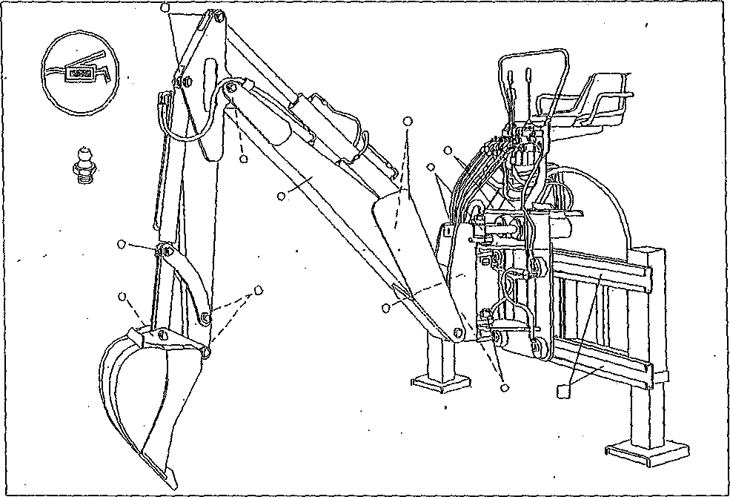
Perform the following checks after a month or after 150 operating hours:
- check the integrity of all the adhesive labels;
- check all the pipes (connection tightening, braiding integrity and hydraulic oil dripping or leaks);
- check the hydraulic oil level of both pump/multiplier group and
tractor/operating machine (see relative maintenance manual);
- clean the hydraulic oil filter;
- check the presence and the integrity of the fastening and safety devices;
- check the tightening of the bolts which lock the various parts of the backhoe;
- check die state of the whole carpentry;
- carry out a backhoe operation test and check, by means of the hearing, that there are not suspicious noises.

E2.3 Yearly check or after 1200 operation hours
Perform the following checks after a year or after 1200 operating hours:
- check all the pipes (connection tightening, braiding integrity and
hydraulic oil dripping or leaks);
- replace completely the bush-cutter hydraulic oil and filter (see the
paragraph about lubricants to carry out such task);
- check the self-acting return of the control levers and the working of all
the operations;
- check the tightening of the bolts which lock die various parts of the bush-cutter;
- check the state of the whole carpentry;
- get an operation and safety test of the hydraulic system performed by a repair shop authorized by die Manufacturer. During this test it will be checked that there are not suspicious noises.

E3 Lubrication

E3.1 Grease supply points
Before supplying with grease the above said points (grease nipples) located on the backhoe and shown in figure, it is necessary, first, to clean them from possible traces of dust and, then, to inject grease by using the grease gun. Lubricate the slide guides, too, using a brush. When the task is completed, remove surplus grease with a rag. Use only the type of grease recommended by the Manufacturer.
- Grease supply points
- Brush-lubricating points
Note: this picture intends to show the places where the grease nipples of both the series are located.

E3.2 Tank oil level check
All the jacks installed on the backhoe are double-acting: should they be completely extended or retracted, the quantity of hydraulic oil in the tank remains nearly unchanged. Therefore, checking the oil level in the tank is a task that can be performed at any moment. Such check is to be carried out looking through the level cap which is transparent and installed on the side of the tank, as shown in figure. If the oil covers the red indicator in the middle of the cap, its quantity inside the tank is enough. Otherwise, restore the level by adding more oil, following the instructions described afterwards.

E3.3 Tank oil level recovery or oil replacement
Level recovery: as for recovering the oil level all it takes is to unscrew die oil inlet cap and pour oil in the tank by using a funnel. When you can see, through the level cap, that the fluid has reached the red indicator, stop supplying and screw the oil inlet cap.
Oil replacement: provide yourself with an enough capacious container and place it under the tank where the outlet plug is located. Unscrew the oil inlet cap and then the outlet plug to allow the hydraulic oil to flow out completely. As the task is over, screw the outlet plug after having replaced the relative gasket. Begin to fill the tank with the oil recommended by the Manufacturer by using a funnel. When you can see, through die level cap, that the fluid has reached the red indicator, stop supplying and screw the oil inlet cap.

E3.4 Multiplier oil level check
In order to perform this check, it is necessary
to keep the pump/multiplier group perfectly
vertical, as shown in figure.
If the oil covers the red indicator in the middle
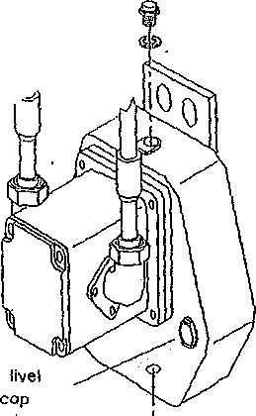of the cap, his quantity is enough. Otherwise,
Intel cop
restore the level following the instructions described afterwards.
E3.5 Multiplier oil level recovery or oil replacement
Oil recovery: as for recovering the oil level, after having checked it, all it
takes is to unscrew the oil inlet cap and pour oil in the multiplier by using a,
funnel. When you can see, through the level cap, that tire fluid has reached
the red indicator, stop supplying and screw the oil inlet cap.
Oil replacement: provide yourself with a small container (capacity 3 1.) and
place it under the multiplier outlet plug. Unscrew the oil inlet cap and then-
the outlet plug to allow the hydraulic oil to flow completely As the task
is over, screw the outlet plug after having replaced the relative gasket. Begin to fill tire multiplier with the oil recommended by the Manufacturer by using a funnel. When you can see, through the level cap, that tire fluid has reached the red indicator, stop supplying and screw the oil inlet cap.

Note; - in any case it is advisable to carry out the drain of the oil when it is hot so as to get the emptying easy. So it would be better to carry out: the task soon after the end of the work. Before beginning this operation, however, set up the backhoe as described in paragraph Fl;
- when recovering the level do not mix different type of oils but always use the same type that is in the tank or in the multiplier carter;
- when replacing the hydraulic oil it is possible to use a different type provided that it has the same characteristics of that recommended by the Manufacturer.
IMPORTANT
To avoid pollution it is absolutely forbidden to disperse oils, lubricants, filter cartridges or other harmful materials in the environment. Comply strictly with the provisions of the law in force in each Country for the disposal of the liquid or solid substances.
E3.6 Hydraulic oil filter check and replacement
The hydraulic oil tank is equipped with a device for the purification of the fluid in it contained. Such device is provided with a high filtering, power cartridge (filter) which purifies the oil when it comes back (releasing phase) to the tank.

As for checking the filter it is necessary to remove the cover, unscrewing the screws, and pull it out from his seat. If the filter is little dirty all it takes is cleaning it by blowing in compressed air (max 2 bar); if it had to be very dirty, instead, it is necessary to replace it. Use only a new filter and of the same type.

IMPORTANT
When using the compressed air it is required to wear goggles with side protections and not to direct the jet of air toward the face or toward people who are in the area.

E4. Troubleshooting
If machine working troubles come out, contact the Manufacturer immediately.

FAILURES OR TROUBLES | CAUSES | SOLUTIONS
No response of controls | - hydraulic system pipes are unconnected | -connect pipes
 | -power takeoff is off  - subsidiary circuit is off  -hydraulic pump is damaged  -lack of oil | -put power takeoff on  - put subsidiary circuit on - - replace pump  - add oil
Stick-s lip-motion of cylinders | air in the hydraulic system | -check the oil level in. the tank  -make the machine run idle for some minutes, using, one after the other, all the jacks so as to get the remained air ejected  - tighten intake pipe connections
Arms and/or stabilizers are in motion without operating the levers | worn-out cylinder gaskets | -replace gaskets  -check distributor wear
Oil overheating | -filter is dirty  -pipes are squeezed  -lack of oil | -replace filter  -check and replace them  -add oil
Oil leakage | - loose connection  -worn-out gasket | - tighten connection  -replace gasket

FAILURES OR TROUBLES | CAUSES | SOLUTIONS
Insufficient penetration of the 'bucket | -worn-out hydraulic pump  -oil shortage | -replace pump  -restore oil level
 | -out-of-setting or worn-out pressure relief valve  -filter is dirty  -oil leakage  -worn-out cylinder gasket | get (lie setting checked in an authorized repair shop  clean filter  find out and stop it  replace gasket
Sliding jam | -sliding stop cylinders are jammed  -switch nonreturn valve is out of use | - raise and unfold the 2 arm .with the empty bucket and jog the 1st arm jack to get a shaking of the moveable-chassis. This should release the sliding stop cylinders  - replace the valve
Moveable-chassis moves on slide guides | -sliding stop unlocked  -oil leakage  -worn-out cylinder gaskets | - shift the switch to sliding stop position  - find out and stop it  - replace gaskets

F.DEMOLITION

F1. Differentiated subdivision of materials and disposal
When the backhoe is put out of service, those parts which could become dangerous for people and environment are to be made harmless. The machine materials which are to be subjected to differentiated subdivision are the following:
- steel
- hydraulic oil
- rubber plastic
- electric wires (optional models).
The disposal of the aforesaid material must be done in compliance with the provisions of the law in force in each Country.

