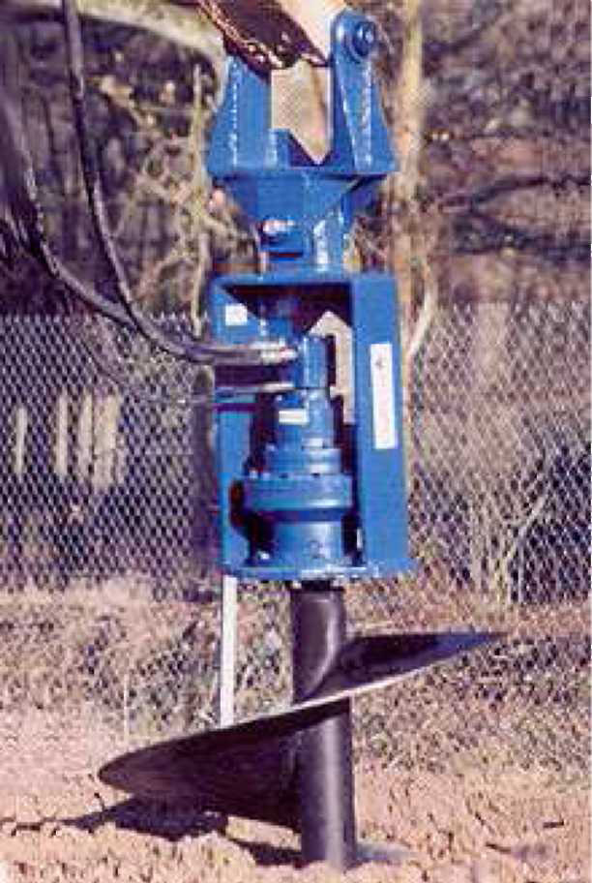

AGRIWAY

Hydraulic Augers
MODEL T

Thank you for buying one of our products. We have used the greatest care to let you receive it in perfect condition. However, please do not hesitate to contact our customer assistance department if you have any problems or questions concerning the goods.
In this handbook the user will find all necessary information for a correct use of the equipment. We ask you to follow the instructions carefully and to keep the handbook with care in a proper and accessible place.

The content of this handbook may be modified without notice, in order to change and improve what has already been included..
We want to make clear that in order to simplify things, in some of the pictures the equipment is shown in a configuration different from the proper one.

1. Conformity Declaration

CE CONFORMITY DECLARATION MODEL

AGRIWAY SRL located in via dell’Industria n°9-9°-9b 60030 Monte Roberto (AN) ITALY -declares on its own responsibility that
Name: AUGER
Model: T
Year of construction:2012
CONFORMS WITH THE LEGISLATIVE REGULATIONS FOLLOWING THE PROVISIONS OF DIRECTIVE 98/37/CE
It declares moreover that it is not allowed to bring the hydraulic auger into operation until the machine to which it will be connected is declared in conformity with the provisions of the Directive 98/37 CE, that means until the equipment to which this declaration refers and the final machine are an only unit.

SIGNATORY IDENTIFICATION
NAME: Michele Bifani / Managing director
Place and date:
2. Symbols
Here below you will find a key to some of the symbols used in this handbook (only to the main ones).

DANGER: this draws attention to problems or situations that can be dangerous for personal safety, including accidents or risk of death.
IMPORTANT: this draws attention to problems or situations which concern the efficiency of the machine, but which are not dangerous as regards personal safety.

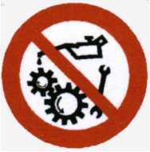
On the machine you will find the following directions:

Danger:
Danger:
IT IS FORBIDDEN TO CROSS OR TO STOP WITHIN OPERATING RANGE OF THE MACHINE.

IT IS FORBIDDEN TO
FIX, ADJUST, OIL OR
CLEAN THE MACHINERY WHILE OPERATING.
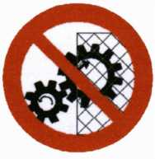

Read the handbook carefully before using the machine.
Danger:
DO NOT REMOVE SAFETY DEVICES AND PROTECTION.

3. Precautions for general use
The operator is personally responsible for equipment security and operation .
Read carefully this handbook before switching on, using, maintaining or operating the machine.
This handbook aims at informing the operator, through pictures and text, about the main regulations to follow when using and maintaining the equipment.
To operate the machine safely you must:
- Check that the machine has not been damaged during transport; if so contact the manufacturer or the area sales representative immediately.
- Allow the machine only to be used by authorized, professionally skilled, adult staff.
- Keep non authorized personnel at a safe distance when the machine is operating.
- Clean the machines regularly, eliminating any foreign materials that could damage the functioning or harm the operator.
- Make sure before using the machine that all the safety devices are properly in place and in good condition. In case the protections are damaged, replace them immediately
- Make sure that all pipes and joints are connected properly.
- Work on machine maintenance only after reading the user's handbook and removing the ignition key from the machine.
- Any repairs must be only carried out by qualified staff using original spare parts; otherwise the user can be seriously harmed.
- Any check on pipes and joints must be carried out with proper safety protections (glasses, gloves and protective clothing to avoid skin contact)
- Do not leave the machine unattended in the working area.
- Do not wear clothing that can get entangled in moving gears like unsuitable clothes, scarves, gowns etc. We recommend the use of clothing in conformity with the normative of work safety, such as helmets, slide-safe shoes, anti-drumming headphones, safety glasses, protective gloves. Ask the employer about the normative of work safety in force and the safety devices in use.


4. Technical features
4.1. Machine description
Hydraulic augers series T have been designed and constructed to bore the soil vertically. Their use is possible only if they are connected to the arm of an excavator. In this way the auger will be supplied by the hydraulic circuit of the machine itself.
The head of the augers can be customised with different kind of augers, for soft or hard soils, and with augers which differ in diameter and length.

4.2. Technical Information

Head | Weight | Oil Flow  Rate  min-max  lts/minute | Shaft Dimensions (mm) | Kind of Engine | Max Work Pressure | Connection Pipes  Min diameter
T1 |  | 12-40 | Hex 50 | ORBITAL | 250 | 1/2 GAS R2
T2 |  | 20-50 | Hex SO | ORBITAL | 250 | 1/2GAS R2

4.3. Machine main parts

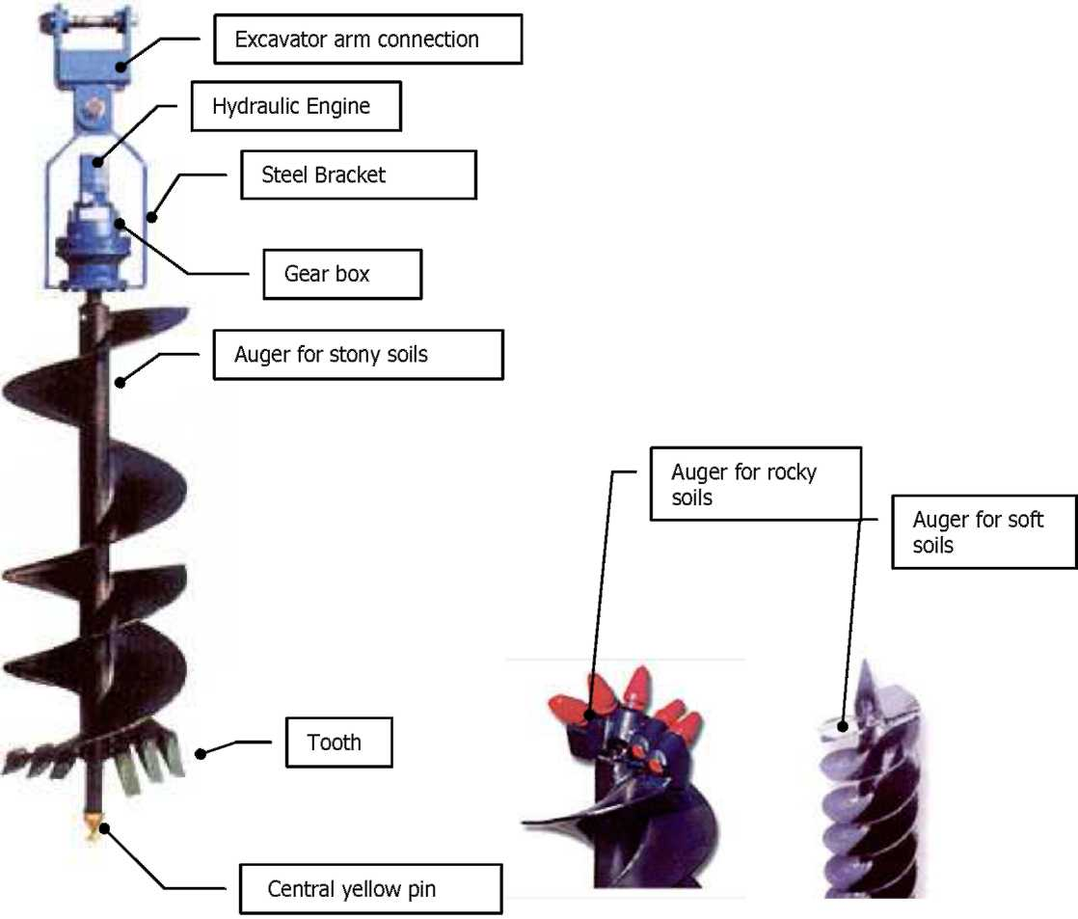

4.4. Environmental conditions
The equipment must not be used at temperatures lower than -10°
The equipment must be used in places which conform with the hygiene and safety on work regulations in force.
- Do not approach the machine with fire or similar.
- Do not use the machine in places which are at risk of explosions or fires.

4.5. Improper uses
The use of the machine to bore kind of soils different from the ones recommended by the builder is not permitted.
• It is strictly forbidden to use the auger on vertical faces, cave ceilings or for underground works.

- Delivery
The auger is delivered on a pallet, completely assembled and properly fastened in a stable position. All the goods are checked carefully before being delivered to the customer.
When receiving the machine, please check that it is completely intact. Otherwise contact immediately our retailer.

Unload the machine with a fork-lift truck or transpallet of adequate load capacity, and put it down on a horizontal and stable surface.

The movement of the loads must be carried out in conformity with the regulations about safety on work in force.
Do not waste the packing around, but keep to the regulations in force in the country where the machine is used.

6.1. Preliminary Check
Before connecting the auger to the excavator arm, check the following:
- Check that the weight capacity of the excavator is adequate to the auger you want to install, considering that it is possible to connect more than one auger ( with different diameters and lengths) to the same machine head;
- Check on the auger the state of the connection double pivot and of all the other parts concerning the connection to the excavator arm (see par. 4.3);
- Remove any detritus from the screw and from other parts of the auger;
- Check that the hydraulic system and the capacity of the excavator are adequate to the kind of head you want to install (see technical features par. 4.2);
- Check the state of hydraulic pipes, joints and fast connections of the excavator (state and capacity);
- Check whether the machine has got a simple or dual acting system.
In case the machine has got a simple acting system, contact a AGRIWAY technician before connecting the auger.

IMPORTANT: Check that the soil you want to bore is compatible with the auger in use.
6.2. Auger-excavator arm connection
In case of head with a non- piston engine, do as follows:
- approach the end of the excavator arm to the excavator arm connection on the auger (see par. 4.3)

- remove the pin from the excavator arm connection
- connect the connection on the auger to the excavator arm, inserting the special pin
- connect all the hydraulic pipes
This procedure must be carried out by qualified staff
In case of head with piston engine, besides these 4 stages you must check the connection of the draining pipe. It must connect directly the piston engine to the tank of the machine and the maximum pressure inside the piston engine must not exceed 2 bars.

The auger must be only connected to machines which are equipped with the 'uomo presente (present operator)' device, to activate the controls
- Switching on
The switching on must be carried out by an only operator. Make sure that no people are in the range of the machine.
The auger can be put in motion (rotary movement) only through the controls of the machine connected to it. Switch the engine of the machine on and wait for some minutes, with the engine and the hydraulic system on, for the oil to reach the right temperature and for air bubbles to be ejected from the hydraulic system. The auger can spin in both directions, but this is possible only if the machine has got a dual acting power-supply circuit. In case of simple acting circuit the auger can spin in one direction only.
- Use
As the auger is connected to the excavator arm, its movements are transmitted by the arm itself, and it is always perfectly vertical, as it is equipped with a double pivot which ensures verticality of the borings. Set the auger where you want to bore the soil and then lower the excavator arm until the auger starts working on the soil.
Guide the movement of the auger through the excavator arm, without pressing too much on it.
The auger can only work vertically and bore the soil downwards. Any other use is forbidden. When working pay particular attention to any oil leakages from the auger connections. Make sure that no obstacles nor hitches are on the working surface.

IMPORTANT: After any boring, stop the auger movement. Never let the auger spin when moving the machine.

6.5. Normal and emergency switching off
To stop the auger (in both normal and emergency condition) you must use the controls of the machine, to stop the oil from flowing to the head. Doing this, the auger will be immediately stopped.
You can find more detailed information about this stage in the excavator handbook.
8. Maintenance
- Before any kind of maintenance, check or cleaning, the auger must be disconnected from the machine.

- Before maintenance the auger must be cleaned with care.
- Proper personal safety devices must be used during all the maintenance stages.
The auger does not need a particular maintenance; however it is good to follow the instructions in the table below.
For the first three points remember to refer to the User's and Maintenance Handbook of the gear box, here attached.
Frequency | Operation | Procedure | In charge
1.After the first 150 hours of work | Change of the oil in the gear box | Change the oil when the gear box is warm and wash the internal parts with special products before pouring in the new oil | Qualified  staff
2.Every 500 hours of work or at least once a year | Change of the oil in the gear box |  | Qualified staff
3.Once a month | Check the level of the oil Visual level on the head | Add oil, if necessary | Qualified staff
4.At the end of the work | Clean the auger with care, removing all the incrustations accumulated during the activity |  | Operator
4.At the end of the work | Check the fast connections and the pipes condition |  | Qualified staff
Do not mix oils different in viscosity and brand. Do not mix mineral oils with synthetic oils.
Make sure that the whole hydraulic system is clean. This will prevent possible damages to the head.
8.1. Auger teeth replacement for mixed soils
Follow the instructions below, with the auger disconnected from the excavator arm, in horizontal position and properly fastened to prevent it from rolling.
- Remove the pin (20)* and the rubber (19)* of the tooth you want to replace;
- Remove the damaged tooth and insert the new one;
- Insert rubber and pin to fix the tooth.

- see table enclosed with this Handbook, par. 11.2.
8.2. Auger replacement
Follow the instructions below, with the auger disconnected from the excavator arm, in horizontal position and properly fastened to prevent it from rolling.
- Unscrew the nut /17)* of the auger and remove screw (28)* and washers (16)*;
- Remove the auger, taking it off the hexagonal shaft of the gear box;
- Insert the new auger and fix it with screw (28)*, washers (16)* and nut (17)*
- see table enclosed with this Handbook par. 11. 2

Any load movement must be carried out in conformity with the safety on work regulations in force.

8.3. Lubricating oil
When checking the level and replacing the oil, refer to the relative handbook here enclosed. Here below you can find a table of the lubricants suggested:

LUBRICANT | -20 C + 5 C | + 5 C + 30 C | +30 C + 50 C | +30 °C + 65 °C
ESSO | Spartan EP 100 | Spartan EP 100 | Spartan EP 320 | Compressor oil LG150
AGIP | Blasia | 100 blasia | 150 blasia 320 | Blasia S 220
ARAL | Degol BG 100 | Degol BG 150 | Degol BG 320 | Degol BS 220
BPMACH | GRXP100 | GRXP150 | GRXP320 | SGRXP220
CASTROL | Alpha SP 100 | Alpha SP 150 | Alpha SP 320 | Alpha SN 6
ELF | Reductelf SP 100 | Reductelf SP 150 | Reductelf SP 320 | Oritis 125 MS-SynthP30
CHEVRON | Non lead.gear | Non lead.gear 150 |  | Non leaded gear 320
GULF |  | EP lubr. HD 150 | EP lubr.HD 320
I. P. | Mellana 100 | Mellana 150 | Mellana 320 | Telesia oil 150
MOBIL |  | Mobilgear 629 | Mobilgear 632 | Glycoyle 22/30 SHC 630
SHELL | Omala oil 100 | Omala oil 150 | Omala oil 320 | Tivela oil SA
TOTAL | Carter EP 100N | Carter EP 150 | Carter EP 320 N
KLUBER | Lamora 100 | Lamora 150 | Lamora 320
ISO 3448 | VG 100 | VG 150 | VG 320 | VG 150-200

8.4. Storage instructions
If not used for a long time, the machine must be stored in a place at a proper temperature (not extreme) and must be protected from atmospheric conditions and possible collisions.

8.5. Problems and solutions
This paragraph aims at supplying the user with solutions to the most frequent problems (malfunctions) that may occur. Do not carry out maintenance or repairs that can affect the machine safety.
The solutions marked with the letter A require the intervention of Our Technical Assistance. The solutions marked with the letter P require the intervention of Qualified Staff. The solutions marked with the letter U can be carried out by the user.
PROBLEM | POSSIBLE CAUSE | SOLUTION
The auger does not spin | It is not fed | See use and maintenance handbook of the main machine | P
 | It does not drain | Disconnect the draining pipe and check whether the auger, with the loose pipe put directly into an empty and clean container, works. If so, the cause must be in the system. For that, consult the use and maintenance handbook of the main machine. | P
The auger spins in one direction only | The feeding hydraulic system is not a dual acting one | Check in the use and maintenance handbook of the main machine | P
The auger spins too fast/slowly | The oil flow capacity of the machine is not | Change head model | A
 | adequate to the head | Change excavator model | P
The auger works with reduced power | The pressure regulated by the pump valve of the excavator is too low | Consult the use and maintenance handbook of the machine | P
Oil leaks from the auger vent | Oil level too high | Lower oil level | P
 | Possible wear on the hydraulic engine | Contact the assistance centres | A
Oil leaks from the auger head | Obstruction of the vent plug | Unscrew and clean the plug with care | P
 | Damaged or worn seals | Replace the seals | P
Excessive noise | Internal fault | Contact the assistance centres | A

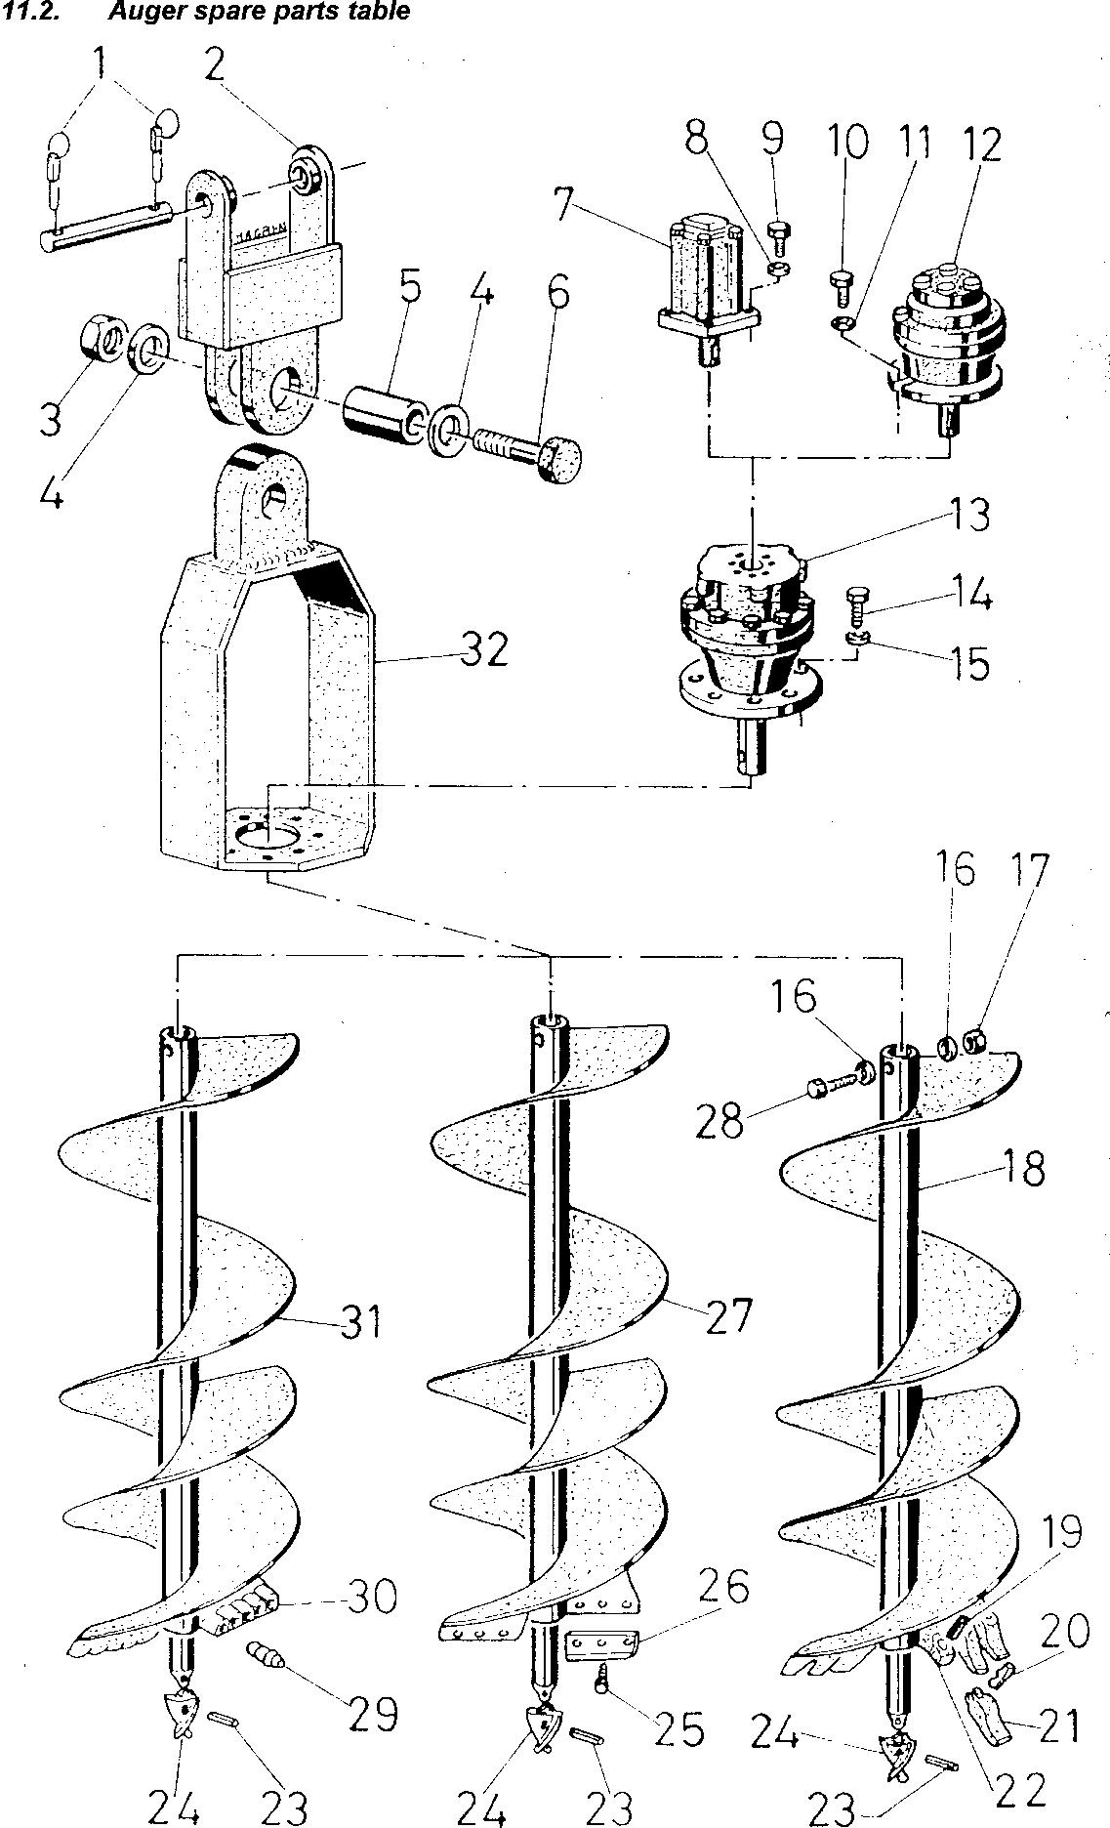

TRIVELLA IDRAULICA HYDRA - LISTA RICAMBI TAV. 01
HYDRA HYDRAULIC AUGER - SPARE PARTS TAB.01

CODICE CODE | DESCRIZIONE | PARTS
1 | COPPIGLIA | PIN
2 | ATTACCO FORCELLA | EXCAVATOR ARM CONNECTION
3 | DADO M30 | NUT M30
4 | RONDELLA 30 | WASHER 30
5 | BOCCOLA | AXLE BOX
6 | VITE M30 | SCREW M30
7 | MOTORE IDRAULICO | HYDRAULIC ENGINE
8 | RONDELLA | WASHER
9 | VITE | SCREW
10 | VITE | SCREW
11 | RONDELLA | WASHER
12 | MOTORE A PISTONI | PISTON ENGINE
13 | RIDUTTORE | GEAR BOX
14 | VITE | SCREW
15 | RONDELLA | WASHER
16 | RONDELLA | WASHER
17 | DADO | NUT
18 | PUNTA PER TERRENI MISTI | AUGER FOR STONY SOILS
19 | GOMMINO | RUBBER
20 | SPINA | PIN
21 | DENTE | TOOTH
22 | SUPPORTO DENTE | TOOTH BRACKET
23 | SPINA ELASTICA | PIN
24 | PUNTA CENTRALE GIALLA (60/100MM) | YELLOW PIN (60/100 MM)
25 | VITE | SCREW
26 | COLTELLO | CUTTER
26 A | SUPPORTO COLTELLO | CUTTER BRACKET
27 | PUNTA PER TERRENI SOFFICI | AUGER FOR SOFT SOILS.
28 | VITE | SCREW
29 | PICCO | ROCKY SOILS TOOTH
30 | SUPPORTO PICCO | AXLE BOX FOR ROCKY TOOTH
31 | PUNTA PER TERRENI ROCCIOSI | AUGER FOR ROCKY SOILS

